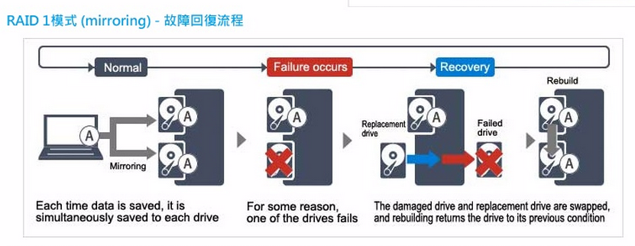

|  |  |  |  |  |
| --- | --- | --- | --- | --- |
|  | **pcs** | **壞pcs** |  |  |
| Raid0 |  |  |  |  |
| Raid1 | 2 |  | copy |  |
| Raid3 |  |  |  |  |
| Raid5 | 3 | 1 | 繼續用 | 計算並回覆 |

為什麼人佇說安捏沒安全,要嗄做xxx

我有一種做賣完的感覺.我欲哭啊